
What is a thermocouple?

A thermocouple is made of a pair of wires of different metals, such as iron and copper, whose ends are welded together. The welded point is called the "junction". When the junctions are at different temperatures, as shown in Figure 1, the thermal electromotive force (emf, millivolt) is generated between them. By measuring the emf, we know the temperature difference.
A pair of junctions between two dissimilar metals generates emf when they are at different temperatures. This phenomenon is called the Seebeck Effect. The emf depends on the combination of dissimilar metals and temperature difference between the junction. However, it does not depend on the shape of the wires and volume of metals used. The emf can be measured with a meter in the circuit (See the figures).
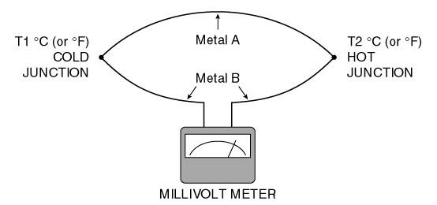
Figure 1
When one junction, called the cold junction or reference junction, is kept at a constant temperature, for example 0°C or 32°F, the emf is determined only by the temperature at the other junction. This junction is called the hot junction or the measurement junction. In such a setup, we know the temperature at the hot junction from the emf.
Figure 2 shows a variation of the Figure 1 setup. In addition to the thermocouple wires A and B, wires of the third metal C, typically copper, are connected. The junction U between metals A and C and the junction V between metals B and C become the cold junction. As long as junctions U and V are at the same temperature T1, the emf between U and V is equal to that of the metals A and B only, like that of Figure 1. Figure 2 represents a typical circuit of a thermocouple transmitter. U and V are the input terminals of the transmitter. Inside the transmitter, copper wires are used for connection between the terminals and the electronic measuring circuit.
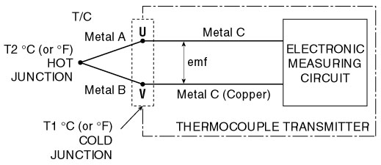
Figure 2
M-System has flexible solutions to meet your specific application and requirements. Consult our Signal Conditioners Data Library. 

