
What is cold junction compensation?

Temperature should be measured with the cold junction at 0°C or 32°F. When a thermocouple or its extension wires are connected to the terminals of a device like a thermocouple transmitter the cold junction is at the room temperature T1°C. If both temperatures of the hot and the cold junctions are above 0°C, the device receives a lower emf than when the cold junction temperature is 0°C. In order to measure the temperature accurately, we need to add the emf value which corresponds to T1 to the measured emf. To add this emf is called cold junction compensation.
The figures show the temperature-emf curve (not to scale) and a temperature measuring setup with a thermocouple and a millivolt meter. Assume the cold and the hot junctions are at T1°C and T2°C, respectively. According to the temperature-emf table of the standard, the thermocouple generates emf of E1 mV at the temperature T1 and E2 mV at T2. The millivolt meter receives the potential difference, E2 - E1 which corresponds to T2 - T1. In order to obtain T2, we need to add E1 to the potential difference, E2 - E1 for elimination of E1.
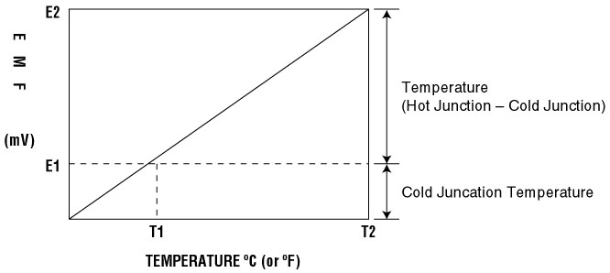
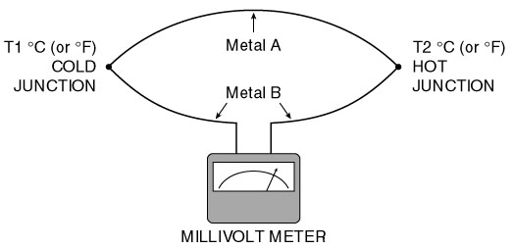
An actual example may better clarify the above discussion. Assume that we are using a Type E thermocouple to measure T2, which is 550°C (1022°F) and the millivolt meter (more accurately speaking, the terminals of the millivolt meter) is at room temperature T1, which is 25°C (77°F). According to the temperature-emf table of Type E, the thermocouple generates (with reference to °C):
41. 045 mV at 550°C
1.495 mV at 25°C
The potential difference is 39.550 mV.
The millivolt meter displays to 39.550 mV, which corresponds to 531.5°C, not 550°C. We must make cold junction compensation by adding 1.495 mV to the potential difference, 39.550 mV.
M-System has flexible solutions to meet your specific application and requirements. Consult our Signal Conditioners Data Library. 

