
Why are extension wires used?

We use extension wires to reduce the cost of a thermocouple temperature measurement system without sacrificing the measurement accuracy.
Ideally, for accuracy, the thermocouple wires should be used to connect the thermocouple and the measuring device all the way through. Long wires in the plant often become expensive, though. (For example, Platinum wires for Type R or S thermocouple!)
On the other hand, if a pair of common copper wires is used for connection of the thermocouple to the devices, the measurement error increases. So, we replace the connection with extension wire of inexpensive metal whose temperature-emf characteristic agrees with that of the thermocouple in the environmental temperature, that is commonly air temperature in the plant.

The figure shows use of extension wires between the thermocouple and a thermocouple transmitter. The extension wires are made of metals D and E.
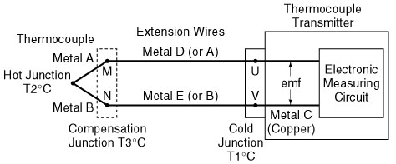
The junctions between metals A and D and between B and E are M and N in the figure, respectively. M and N, which are called compensation junctions, should be at the same temperature (T3°C)- not necessarily constant.
The temperature-emf characteristic of the metals of the extension wires agrees with that of the thermocouple in the narrow temperature range of the plant environment. Therefore, the emf at the input of the thermocouple transmitter corresponds to the temperatures of the hot and cold junctions, T1 and T2.
There are two types of extension wires. One type uses the same materials as the thermocouple (Metal D = A, Metal E = B) and the other type uses different metals from the thermocouple, as discussed above. They are called the extension type and the compensation type, respectively. The extension type provides a high accuracy even with wide temperature changes in the environment, although it is generally more expensive than the compensation type. For a thermocouple of inexpensive materials, like Type J and T, thermocouple metals are used for the compensation wires. The compensation type is low in cost, although its usable temperature range is narrow. You should choose extension wires to meet your application requirement.
M-System has flexible solutions to meet your specific application and requirements. Consult our Signal Conditioners Data Library. 

