
What is a thermocouple with a thermo-well?

It is a thermocouple assembled in a thermo-well. See the drawing for its typical construction. A thermo-well protects the thermocouple wires from physical and environmental damage. Before assembling, the thermocouple wires are insulated with insulation tubes.

Its emf characteristic deteriorates and its life is shortened in applications when the thermocouple has no protection against external vibration, oxidizing or reducing atmosphere, metal vapor and other aggressive chemicals. We can stabilize its characteristics for a long period of time when we protect it from direct exposure to external condition by using a thermo-well. Another name for the thermo-well is a protection pipe (tube).
Materials of thermo-wells for low temperature applications are PVC, polyethylene, Teflon* and the like. For high temperature ceramics are used. There are also metal thermo-wells, typically of stainless steel. Metallic or nonmetallic pipe is selected depending upon application requirement.
The drawing shows typical construction of a thermocouple with a thermo-well. Other common designs are thermocouples with insulated coating and sheath-type structure.
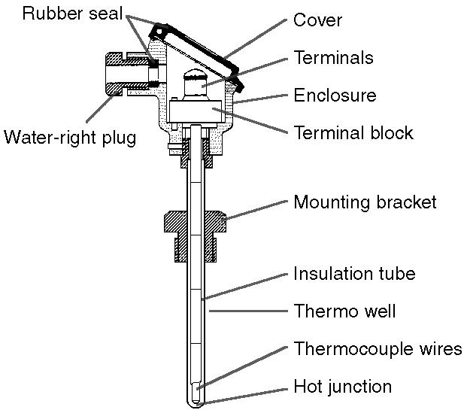
*Teflon is the DuPont Company's trade name.
M-System has flexible solutions to meet your specific application and requirements. Consult our Signal Conditioners Data Library. 

