
How does M-System provide cold junction compensation in its thermocouple transmitter?

The input terminal of the thermocouple transmitter becomes the cold junction when the thermocouple or the extension wires are connected to the transmitter. We need to measure the terminal temperature accurately for cold junction compensation.With M-System Models M2XT and M2TS Thermocouple Transmitters, we mount a sensitive, accurate temperature sensor directly on the input terminals as shown in the figures. We call it a direct-mounting cold junction temperature sensor.
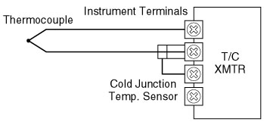
We add the emf corresponding to the cold junction temperature T1 (referenced to 0°C or 32°F) to the measured emf. After the addition, the sum of emf's is converted to the measured temperature.

The cold junction temperature sensor should have high thermal conductivity, low thermal mass and a good linearity to temperature. With Models M2XT and M2TS Transmitters, a thermistor is used as the cold junction temperature sensor, since its base-emitter forward junction voltage has the desirable temperature characteristic. It is mounted on a metal piece for small size and heat conductivity. In Model M2XT PC Programmable Thermocouple Transmitter, we use its microprocessor for a higher accuracy. It determines the compensation emf for each type of the thermocouple from the sensor temperature. Model M2TS Thermocouple Transmitter uses an analog circuit for generating the emf for the cold junction compensation.
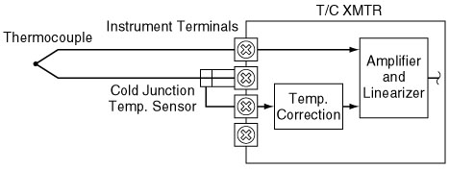
M-System has flexible solutions to meet your specific application and requirements. Consult our Signal Conditioners Data Library. 

