
What is burn-out thermocouple?

The thermocouple burn-out function is mostly used in a temperature control system with a thermocouple input.
If the thermocouple burns out, the controller loses the input signal. This is equivalent to the measured temperature becoming very low. Then, the controller responds by trying to increase the heat typically, overheating the process, like a furnace.
In order to prevent the overheating, a burn-out function is provided with the transmitter. The simple circuit of burn-out function generates a dummy signal of a high emf when the thermocouple or the extension wires' circuit opens. It drives the transmitter output higher than the 100% (or lower than 0%, if so chosen.) The controller will respond to the higher-than 100% signal to lower the controlled output. The temperature control system with the burn-out function prevents overheating of the process in a case of thermocouple burn-out.

M-System Model M2XT and M2TS Thermocouple Transmitters have three options of the burn-out function:
- The output signal becomes higher than 100%. (Upscale burn-out)
- The output becomes lower than 0%. (Downscale burn-out)
- No burn-out function
Option 1 is the standard design. In some temperature control systems it is safe to use option 2 or 3.
A burn-out circuit is shown in the figure below. The positive input of the operational amplifier of the measuring circuit is connected to the positive (or negative) power supply through the high-value resistor R. R resistance is so high that the current through it is as low as 0.1mA. The current has only negligible effect on temperature measurement when the thermocouple circuit is closed, since it is diverted toward the thermocouple circuit whose resistance is low. We call the current a burn-out current. When the circuit opens by burn-out or disconnection of the input wire, the burn-out current changes the amplifier output to drive the transmitter output higher than 100% (or lower than 0%).
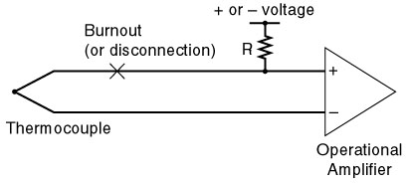
M-System has flexible solutions to meet your specific application and requirements. Consult our Signal Conditioners Data Library. 

