
We need to connect a recorder and thermocouple transmitter in parallel with the extension wires from a thermocouple. Is there any problem in the connection?

A block diagram of the parallel connection in question is to the right. It is a common practice to use a recorder having a burn-out function. If you use the transmitter output only for temperature monitoring, you may use a thermocouple transmitter with or without burn-out function together with a recorder having the function.
If you, however, use the transmitter and the recorder having a burn-out function in a temperature control system, it is recommended the thermocouple transmitter does not have the burn-out function.
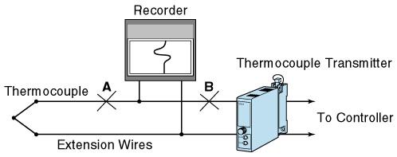
For process safety, parallel connection of a recorder and a temperature transmitter both with burn-out function is not recommended in a temperature controlled system. The burn-out circuit of two instruments may interact with each other, causing measurement errors. There still remains a problem of using a transmitter without burn-out function in the drawing. If the thermocouple circuit is open at point A, there may be no problem since the transmitter may detect the burn-out current of the recorder and respond to it, driving its output to above 100%. If the circuit is open at B, the transmitter cannot detect the burn-out current of the recorder and the output undesirably changes.
We recommend the connections shown in Figure 1 or 2. In Figure1, the recorder and the controller are connected in parallel to the transmitter output, eliminating all problems discussed above. In Figure 2, a pair of the thermocouples is used (twin thermocouples). The recorder and the thermocouple transmitter are individually connected to each thermocouple. In some critical applications the redundant system of Figure 2 is used.
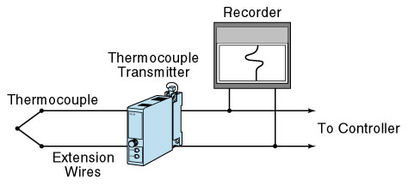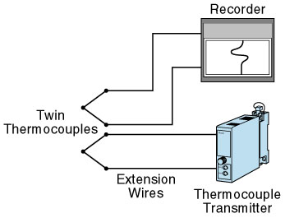
Figure 1 Figure 2
M-System has flexible solutions to meet your specific application and requirements. Consult our Signal Conditioners Data Library. 

