
How can we obtain a linearized signal from a thermocouple?

A linearizer, analog type or digital type, is required to obtain the signal proportional to the measured temperature, since the emf of a thermocouple is not linear. M-System Models M2XT and M2TS Thermocouple Transmitters contain the linearizing function. When you use these transmitters, you do not need a separate linearizer.

There are two types in linearization - one is analog and the other is digital.
Model M2TS Thermocouple transmitter uses the analog linearization. We curve-fit the temperature-emf curve with seven (7) segments of linear lines within the instrument accuracy specification, for each thermocouple type and the measuring ranges. The curve-fitting is shown in the figure. By using the linear segments, the transmitter generates its output, e.g. 4-20mA DC directly proportional to the measured temperature.
Model M2XT Thermocouple transmitter, containing a microprocessor, uses digital linearization. It stores the temperature-emf tables at 1°C increments. Within the increment, the microprocessor calculates the measured temperature by proportioning.
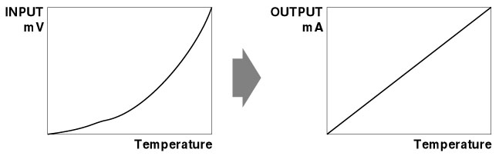
M-System has flexible solutions to meet your specific application and requirements. Consult our Signal Conditioners Data Library. 

