
How can we display the maximum and the minimum temperatures measured with a thermocouple transmitter?

We recommend M-System Model M2PHS Peak-Hold Unit. In this unit, the maximum value is held by the H-hold function and the minimum value is by the L-hold function. As shown in the figure, connect Peak-Hold Units to the output of a thermocouple transmitter. Then leave the connection between terminals 5 and 6 open. They will hold the peak (maximum) and the valley (minimum) value, respectively, and generate the outputs corresponding to the values held.
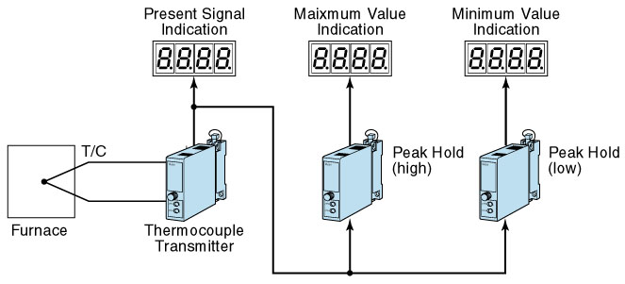

By momentarily connecting Terminal 5 to Terminal 8 of the unit, you can reset its peak value. At that moment, the output signal is equivalent to the input signal.
For parallel connection of two Peak-Hold units, the input signal to Peak-Hold Units should be a voltage signal.
M-System has flexible solutions to meet your specific application and requirements. Consult our Signal Conditioners Data Library. 

