
How can we generate alarm signals when the difference between two temperatures exceeds the limit? We need alarms for the plus and the minus deviation separately.

Use M-System Model AYDV Deviation Alarm with two thermocouple transmitters, for example Model M2XT or M2TS, as shown in the figure.
The Deviation Alarm has two relay contact outputs: Output 1 is for the plus deviation alarm and Output 2 is for the minus deviation alarm. The signal from the first thermocouple transmitter is called the reference signal and that from the second transmitter is the measured signal.
If (measured signal) < (reference signal), then the deviation is minus (-).
If (measured signal) > (reference signal), then the deviation is plus (+).
The plus and minus alarm limits can be set separately.
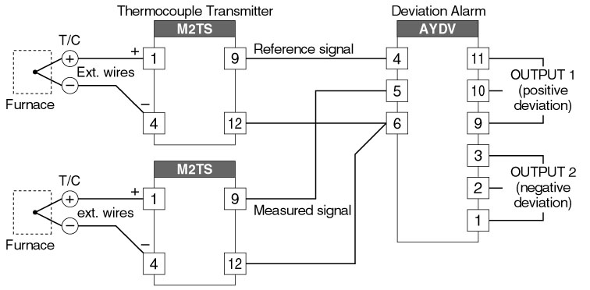
M-System has flexible solutions to meet your specific application and requirements. Consult our Signal Conditioners Data Library. 

