
How can we generate alarm signal when a measured temperature is beyond the set point?

Use M-System Model AS or ASL DC Alarm. As shown in the figure, DC Alarm is connected to the output of a thermocouple transmitter, for example M-System Model M2XT or M2TS. You may set the upper and the lower alarm limits in the DC Alarm. When the input is outside of the alarm limits, the corresponding output relay contact, or the open collector if so specified, closes. You may use the relay contacts to actuate an alarm buzzer or turn on an alarm lamp.

In Model AS and ASL DC Alarm, the alarm limits are set with pots which are accessible from the front of the enclosure. At the High and the Low Setpoint Monitor terminals on the front panel, the set value can be monitored with a DVM. The voltage at the monitor terminals changes between 0 and 10V DC, corresponding to 0 to 100%.
When you need only high and low alarms, you may replace the thermocouple transmitter and DC Alarm with one instrument, M-System Model ALT or ATC. Thermocouple Alarm Model ALT uses digital dials for limit setting; Model ATC uses pots.
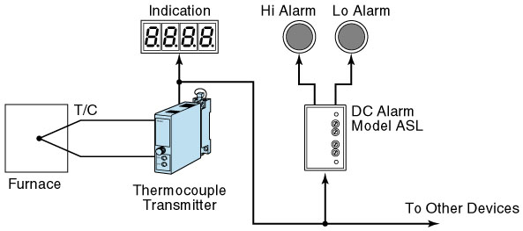
M-System has flexible solutions to meet your specific application and requirements. Consult our Signal Conditioners Data Library. 

