
How can we protect a thermocouple from lightning?

In a case of a long transmission distance between the thermocouple and the thermocouple transmitter, a lightning surge may enter the extension wires and destroy the transmitter. We recommend installing M-System Model MDP-TC Lightning Arrester for Thermocouples onto the extension wires, close to the transmitter.
The lightning arrester must be properly grounded. The arrester will protect the transmitter by diverting the lightning energy to ground, except in a direct lightning hit.

The lightning surge induced onto the extension wires propagates not only to the thermocouple transmitter but also to the thermocouple. To protect the thermocouple, another Model MDP-TC Lightning Arrester for Thermocouples should be installed closely to it, as shown in the figure. The temperature at the location of the lightning arrester must not change suddenly but be stable, or a measurement error will increase.
When we install a lightning arrester onto the extension wires, we insert metals that are different from the thermocouple and the extension wires. If the temperature at their connections is not the same, an error emf is generated. The longer the extension wires outside a building, the higher the possibility of lightning damage.
When the length of the extension wires becomes longer than 30 meters (100 ft) outside the building, you should start investigating the need of lightning arresters.
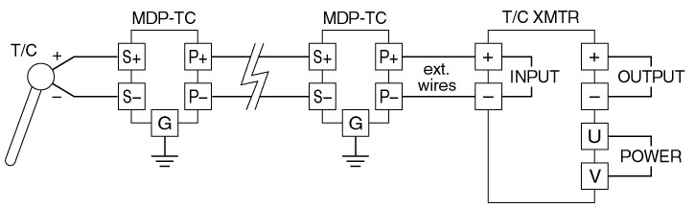
M-System has flexible solutions to meet your specific application and requirements. Consult our Signal Conditioners Data Library. 

