
What is the electric power in an electric circuit with a pure resistance?

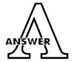
The power in a pure resistance circuit is given by,
where, P = V x I
P: electric power
V: effective value of the alternating voltage
I: effective value of the alternating current
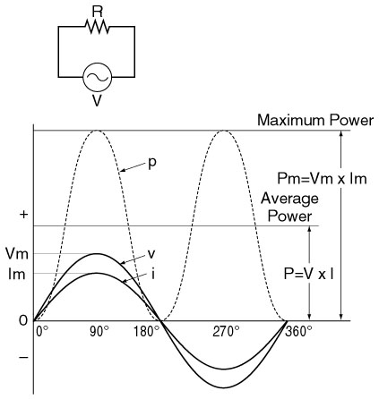
An instantaneous value of a pure resistance circuit and waveforms are shown in the figure (above).
p = vi
where, v = instantaneous voltage, I = instantaneous current. A maximum power (Pm) is calculated by;
Pm = Vm x Im
where, Vm and Im are the peak value of the voltage and the current, respectively. An average power is Pm/2. Therefore, we obtain
P = Pm / 2 = (Vm x Im) / 2 = Vm / 1.4142 x Im / 1.4142 = V x I.
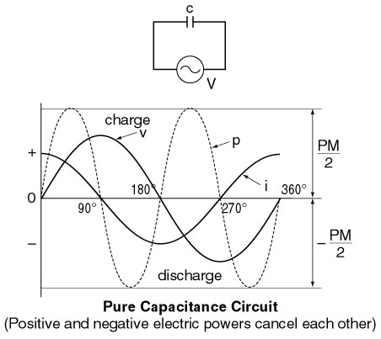
This indicates that the power can be calculated by using the same formula of a DC circuit when we use the effective value of the current and the voltage. Examples of a pure capacitance circuit and a pure inductance circuit are shown the left. There is no consumption of electric power. (In actual circuits, there is some consumption of electric power since a capacitor and an inductor have some resistance associated with them.) Positive electric power and negative electric power cancel each other, and the total power becomes 0 watt.




