
What is bi-directional power flow?


Bi-directional power flow in an electric power supply system is power flow in two opposite directions like tide. Bi-directional power flow occurs daily at factories that consume electricity from the electric power company and from an in-plant electric power generator, as well.
As shown in the left figure below, some facilities (loads) in the factory receive electric power from the electric power company and the others from the in-plant electric power generator at a time. When some facilities are stopped for some reason, for example, maintenance, as shown in the right figure below, the factory has excess electric power from the in-plant electric power generator. By changing the switch connection, this excess electric power is supplied to the facilities that were receiving the power from the electric company. In such a case, bi-directional power flow occurs. See the flow direction at the wattmeters.

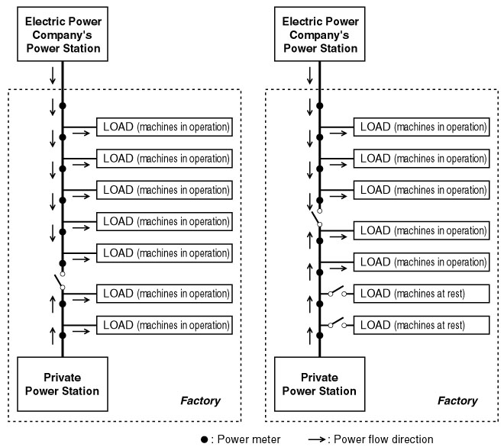

In the future, if solar power generators or wind power generators become common for residential use, surplus of electricity generated by these generators may be fed to an electric company. Then, the residential electric system will have bi-directional flow.
M-System provides power transmitter such as model LWT and model LTWT whose output is in proportion to the forward power without being affected by bi-directional power flow.
■

