
Why does phase difference occur? What is power factor?

The phase angle of the current in reference to the voltage changes depending upon the characteristic of the load. Electric current phase angle does not change if the load is a pure resistor (0 degree phase difference). However, it advances by 90 degrees if the load is the pure capacitor. On the other hand, it lags by 90 degree if the load is the pure inductor. Therefore, the phase difference changes depending upon the resistance, the capacitance and the inductance that the load has.
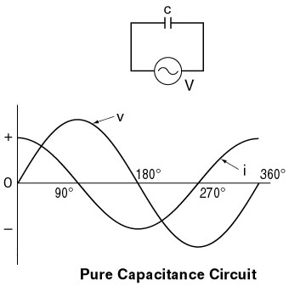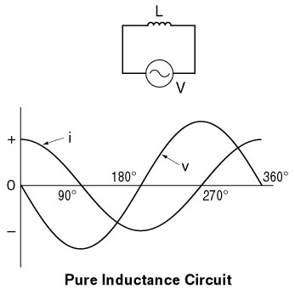
Power factor is cosine of the phase difference between voltage and current. It is a proportion of the apparent power, voltage and current that effectively becomes power. The lower a power factor, the higher the required electric power supply; therefore an electrical facility becomes larger. Generally, a power factor lower than 85% is considered a low power factor. M-System Model LPF or LTPF Power Factor Transducer is useful to manage the power factor. Typical power factors of electric devices are as follow:

Devices | Power Factor | Devices | Power Factor
Incandescent bulb | 100% | Three-phase induction meter | 70 – 85%
Electric heater | 100% | Fan | 65 – 85%
Electric stove | 100% | Fluorescent light | 60 – 70%
Iron | 100% | Motor (sewing machine) | 50 – 80%
Color TV | 90 – 95% | AC welding machine | 30 – 40%
Stereo | 0 – 95%
■

