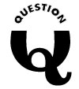
Why does waveform get distorted?

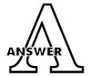
An electric company provides alternating current that is cleanly sinusoidal in the waveform. However, if sinusoidal waves of different frequency, square wave, thyrister controlled waveform and inverter waveform interfere the fundamental waveform by some causes, it is disturbed and distorted.

When the waveform is distorted, it may change the speed of rotation of an AC motor and cause pulsation in its torque. You should be aware, when measuring electric current and power, that you may not obtain an accurate measurement with some measuring devices that are originally desired for measurement of sinusoidal wave.




