
What does the CT protector (M-System model CTM) that is installed onto the socket of the transmitter do?


M-System Model CTM CT protector prevents damaging the primary current transformer (CT), when the CT transmitter is unplugged while CT is alive.

A CT transmitter, like M-System Model CT, receives 0-1Aac or 0-5Aac current signal from the primary current transformer (CT) and converts it to the standard DC output signal. Unplugging the transmitter from its socket, while it is receiving the current from CT, will open the CT secondary circuit: This induces a surge voltage at CT, burning the CT coil. M-System Model CTM CT Protector prevents the CT secondary circuit from becoming open and protects CT, even when the transmitter is unplugged.

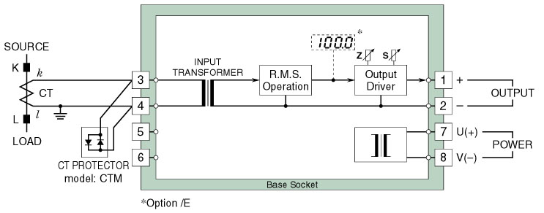

Note: We do not provide a protector, like the CT protector, with the socket of M-System Model PT transmitter which receives the AC signal from the connected potential transformer (PT). PT does not generate a damaging surge voltage even if the transmitter is unplugged. Therefore, PT does not require a protector.
■

