
Is there a way to protect electronic instruments from a direct lightning strike?

Nothing can protect from a direct lightning strike. A lightning rod is the only way to divert direct strikes.

With existing electronic technology, there is no way to protect instrumentation from a direct lightning strike. A lightning rod or overhead grounding wire is still the best protection available from the severity of a direct lightning strike. They protect by shielding electrical conductors and instruments within the protected area.
• Lightning rod
This is set up for buildings with heights greater than 60 feet. It protects electrical instruments from direct lightning strikes by floating the surge's current with respect to ground. The shield angle range is between 45-60 degrees conic.
Simply burying cables is not effective due to the induced electromotive force that occurs around the cable because of impulse current in the ground near a lightning strike.

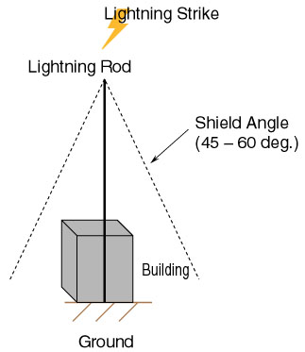

• Overhead grounding wire
This is a grounding wire which is attached to an overhead transmission line. Its effect is similar to having several lightning rods in a row which shields the lines under them from the lightning strike.
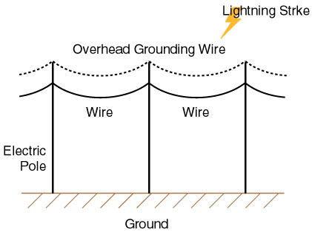
M-System has flexible solutions to meet your specific application and requirements. Consult our Signal Conditioners Data Library. 

