
A control room instrument was damaged during a recent lightning strike. What can be done to prevent this damage in the future?
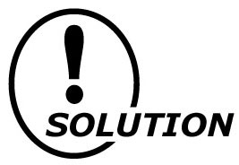
If possible, determine exactly where the lightning entered the instrument. In all probability, it entered through the input signal line or power supply line. We would recommend that you use a protector on both the signal and power supply lines. Contact your local sales office for specific models for your application.

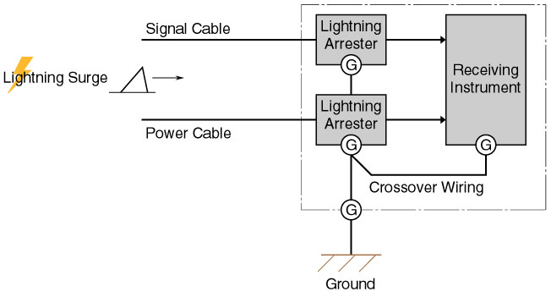

Model | Function & Features
MDP-24-1 | 4-20mA DC & Pulse signal lines
MDM2A-24 | 4-20mA DC & Pulse signal lines with Life monitor function
MDPA-24 | 4-20mA DC & Pulse signal lines with Life monitor function and degradation checker
MA-100 / 200 | Power supply lines 100-120V or 200-240V AC; 2A
MAX-100 / 200 | Power supply lines 100-120V or 200-240V AC; 5A
MAA-100 / 200 | Power supply lines 100-120V or 200-240V AC with Life monitor function; 5A
MAAC-100 / 200 | Power supply lines 100-120V or 200-240V AC with Life monitor function and surge counter; 5A

M-System has flexible solutions to meet your specific application and requirements. Consult our Signal Conditioners Data Library. 

