
A transmitter that is attached to a panel located indoors was damaged by a recent lightning strike. Can you explain why this occurred?

Signals and power sources are commonly connected to a transmitter through outdoor cable pits and conduit pipes. It sounds like the lightning surge damaged the transmitter by means of these lines. If the transmitter's output is sent outdoors, then install lightning surge protectors to protect the input, power and output lines.

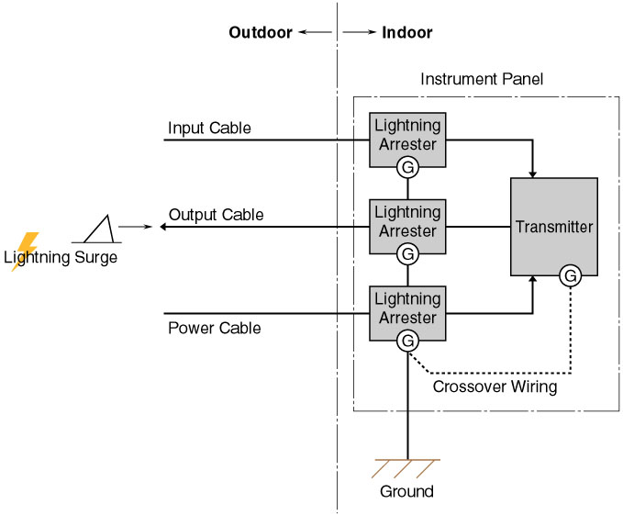
Model | Function & Features
MDP-24-1 | 4-20mA DC & Pulse signal lines
MDM2A-24 | 4-20mA DC & Pulse signal lines with Life monitor function
MDPA-24 | 4-20mA DC & Pulse signal lines with Life monitor function and degradation checker
MA-100 / 200 | Power supply lines 100-120V or 200-240V AC; 2A
MAX-100 / 200 | Power supply lines 100-120V or 200-240V AC; 5A
MAA-100 / 200 | Power supply lines 100-120V or 200-240V AC with Life monitor function; 5A
MAAC-100 / 200 | Power supply lines 100-120V or 200-240V AC with Life monitor function and surge counter; 5A

