
Is a lightning surge protector necessary for a power source line?

Yes, spikes and surges often propagate through power lines.

The most likely place for a lightning strike is the power distribution cables. These spread in all directions, like a spider's web, acting similar to an antenna waiting to receive its signal. Please select the appropriate protector for your specific application and power requirements.
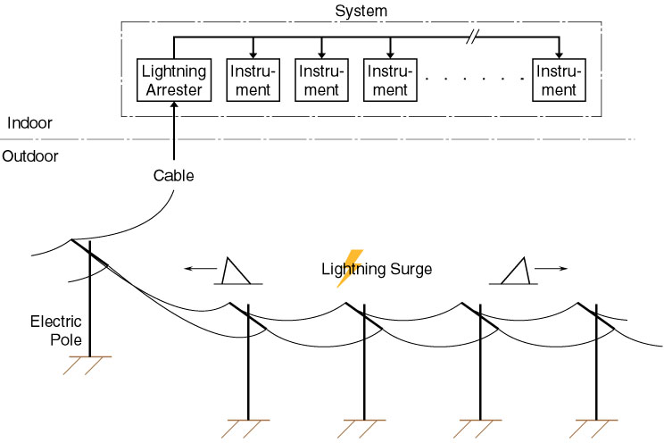

Recommended Model | Function & Feature
MA-100 / 200 | 100 / 110 / 120V or 200 / 220 / 240V AC; Current capacity 2A
MAX-100 / 200 | 100 / 110 / 120V or 200 / 220 / 240V AC; Current capacity 5A
MMAH-100 / 200 | 100 / 110 / 120V or 200 / 220 / 240V AC; Current capacity 10A
MMH-110 / 210 | 100 / 110V or 200 / 220V AC; Current capacity 10A
MMH-130 / 230 | 100 / 110V or 200 220V AC; Current capacity 30A

M-System has flexible solutions to meet your specific application and requirements. Consult our Signal Conditioners Data Library. 

