
During a recent lightning storm, the power was turned off but some instruments were still damaged. Can you explain this?

Lightning jumped across the single-pole switch into the instrumentation. We would recommend to use a double-pole switch. However, this does not insure that a severe lightning surge will not damage it depending on the insulation resistance of the switch or the size of the lightning pulse. The only sure solution is to install a lightning surge protector in line with the power source.

- Single-pole switch
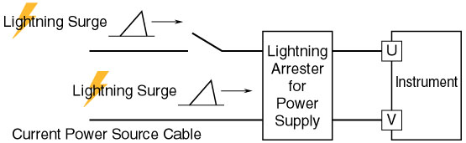
- Double-pole switch
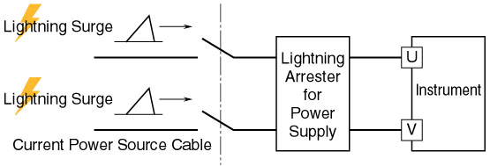
Model | Function & Features
MDP-24-1 | 4-20mA DC & Pulse signal lines
MDM2A-24 | 4-20mA DC & Pulse signal lines with Life monitor function
MDPA-24 | 4-20mA DC & Pulse signal lines with Life monitor function and degradation checker
MA-100 / 200 | Power supply lines 100-120V or 200-240V AC; 2A
MAX-100 / 200 | Power supply lines 100-120V or 200-240V AC; 5A
MAA-100 / 200 | Power supply lines 100-120V or 200-240V AC with Life monitor function; 5A
MAAC-100 / 200 | Power supply lines 100-120V or 200-240V AC with Life monitor function and surge counter; 5A

M-System has flexible solutions to meet your specific application and requirements. Consult our Signal Conditioners Data Library. 

