
An instrument was blackened by a lightning strike via a lightning rod. Is there a reason for this?

It seems like the lightning rod and the lightning surge protector (instrument) share a common ground. We would recommend to separate their grounds from each other.

The large lightning surge energy has caused an isolation breakdown in the instrument. The lightning strike enters the instrument through the ground line of the lightning rod. The instrument's ground and the lightning rod's ground should have enough distance separation between them.
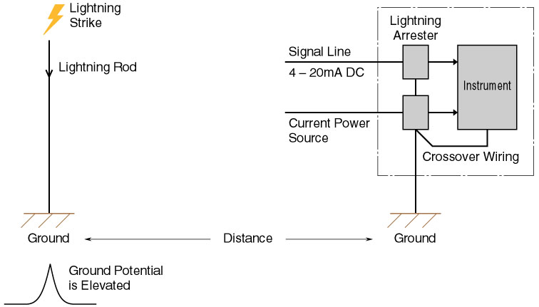
Model | Function & Features
MDP-24-1 | 4-20mA DC & Pulse signal lines
MDM2A-24 | 4-20mA DC & Pulse signal lines with Life monitor function
MDPA-24 | 4-20mA DC & Pulse signal lines with Life monitor function and degradation checker
MA-100 / 200 | Power supply lines 100-120V or 200-240V AC; 2A
MAX-100 / 200 | Power supply lines 100-120V or 200-240V AC; 5A
MAA-100 / 200 | Power supply lines 100-120V or 200-240V AC with Life monitor function; 5A
MAAC-100 / 200 | Power supply lines 100-120V or 200-240V AC with Life monitor function and surge counter; 5A

