
How much resistance is appropriate when grounding the M-RESTER?
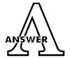
100 ohms or less.

The important thing to remember is that the device ground should be connected with a crossover wire. Then ground is at the potential lightning site. As a result, between the signal line and the ground terminal (G) of an instrument, discharge voltage (Ve) of the lightning surge protector can be added.
• Separate wiring  A common-mode voltage V1, ground resistance (R) x lightning surge current (i), is added to discharge voltage V2 at the lightning surge protector between the signal line and a ground terminal of an instrument. It may go over the withstand voltage of the instrument. | 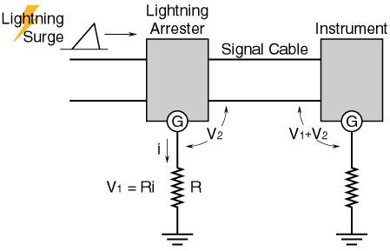
• Wiring at instrument site  Voltage V1, suitable to a drop in voltage at a connected ground point, is added to discharge voltage V2 at the lightning surge protector, then added between the signal line and a ground terminal of an instrument. | 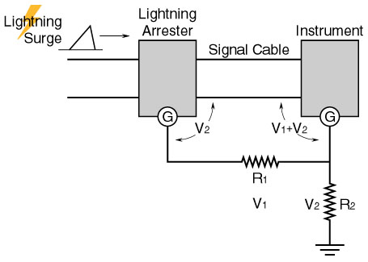
• Crossover wiring  Only discharge voltage in a lightning surge protector site can be added to the space between the common and the signal line of an instrument. The instrument should be protected. | 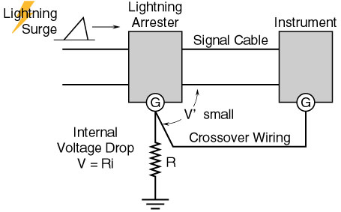
M-System has flexible solutions to meet your specific application and requirements. Consult our Signal Conditioners Data Library. 

