
Is an instrument safe if the lightning surge protector on the power supply line is damaged?

Yes, it’s because the lightning surge protectors have internal protection circuits.

Impulse voltages from a lightning surge can damage a discharge element. After this damage occurs, the current continues to flow once the voltage has fallen below the maximum levels. Each protector has a protection circuit for this specific situation.
- MA-100, MA-200
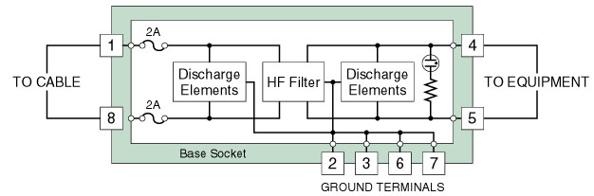
- MAX-100, MAX-200
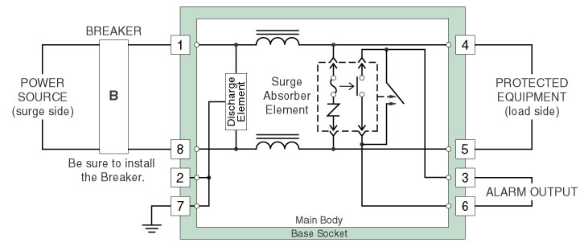

M-System has flexible solutions to meet your specific application and requirements. Consult our Signal Conditioners Data Library. 

