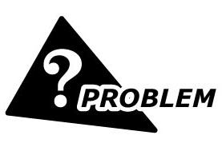
A field transmitter was connected to a lightning surge protector, but it was still damaged by a lightning strike. Can you tell me why?
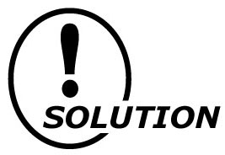
Perhaps the transmitter was subjected to a direct strike. Nothing can protect against this most severe form of lightning. Also, the selected lightning surge protector could have been incorrect for that specific application.

The maximum surge voltage of a lightning surge protector to be used should be below the withstand voltage of the instrument(s) to be protected. This voltage level could be passed through the protector to the instrument(s) during a lightning surge. Be sure to confirm this specification before selecting the protector. Damage to protected equipment may occur because of this variable.
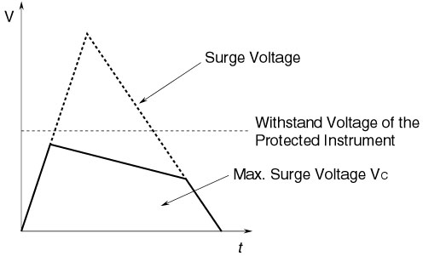
M-System has flexible solutions to meet your specific application and requirements. Consult our Signal Conditioners Data Library. 

