
After a lightning storm, there was no input from the remote RTD sensor to the temperature transmitter. There is no detectable damage to the transmitter. What could have happened?

It seems that the RTD temperature sensor was the only device damaged by the lightning surge.

It is recommended that a lightning surge protector be installed to protect the RTD sensor. If not, then the temperature transmitter's output signal could go upscale or downscale if this sensor is destroyed by a lightning surge. This means excessive down time for the process that is being monitored and controlled.

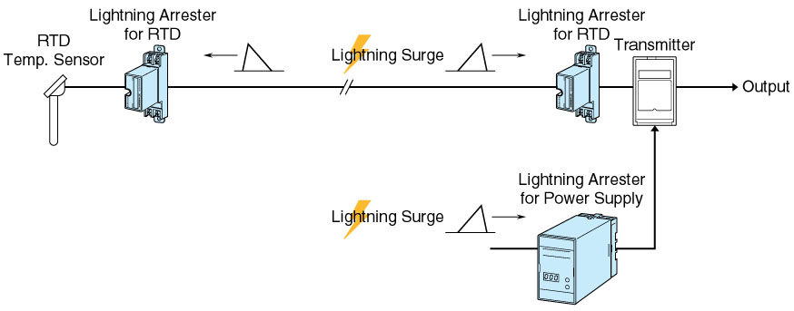

M-System has flexible solutions to meet your specific application and requirements. Consult our Signal Conditioners Data Library. 

