
I want to convert the difference (absolute value) of two (2) signals A and B 4 – 20mA DC.

The connection depends on whether the signals are voltage or current.
Voltage signals (e.g. 0 – 10V DC)
Connect as in Figure 1, and you will get the difference (-10 to +10V DC) of voltage signals A and B. Convert this signal to V-shape signal (4 – 20mA DC) with 0V input as valley with our Linearizer (model: M2XF).
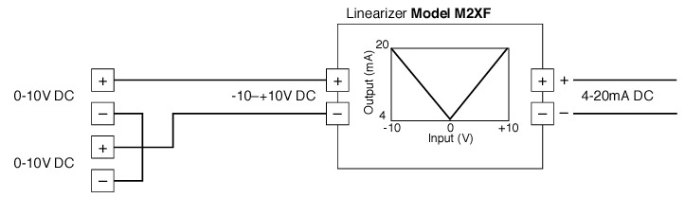Figure 1
Current signals (e.g. 4 – 20mA DC)
Connect as in Figure 2, and you will get the difference of current signals A and B as voltage signal (-4 to +4V DC) with 250Ω resistor. Convert this signal to V-shape signal (4 – 20mA DC) with 0V input as valley with the Linearizer (model: M2XF).
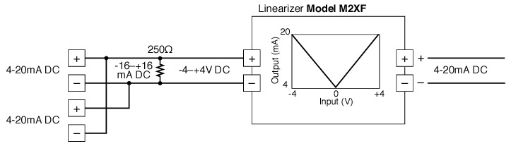Figure 2
You can get the difference (absolute value) of 2 signals with a single Linearizer model M2XF.
M-System has flexible solutions to meet your specific application and requirements. Consult our Signal Conditioners Data Library. 

