
I would like to transmit instantaneous value (4-20mA dc) of CT current (0-5A ac) on a power panel in the field to a monitoring room as well as get a high alarm contact signal. However there is not instrument power on site and transmitters cannot be installed there. Do you have a solution?

We propose our 2-wire CT Transducer model BCT and 2-wire Transmitter Alarm model ALDY. In case wiring outside, our Lightning Arrester for Standard Signal Line model MDP-24-1, and our Isolator model M2VS to isolate the signal (4-20mA DC) from the field to a receiving instrument are also recommended (refer to the Figure).
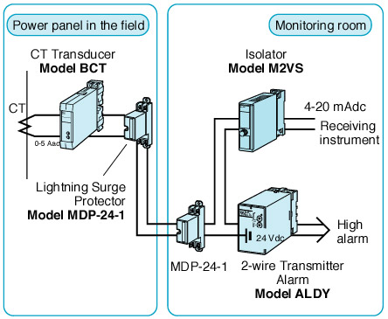
M-System has flexible solutions to meet your specific application and requirements. Consult our Signal Conditioners Data Library. 

