
The standard M2VS output is up to 12V, but I need 0-15V dc.

- Special unit is available. Accuracy and temp. coefficient is the same as the standard M2VS.
- You can also use two of the standard M2VS or the W2VS units, by special wiring.
Solution A) If 500 ohms input resistance is too large, 100 ohms (50 ohms x 2) can be used.
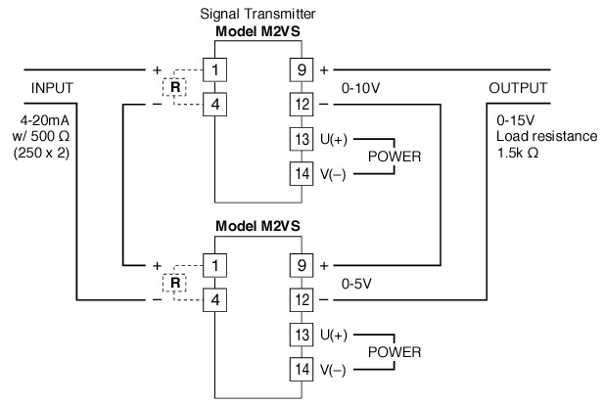
Solution B) Load resistance is not as good as in the M2VS solution.
