
I plan to indicate a flow signal 4-20mA DC (corresponding to 0-2000 l/h) used in a plant on two indicators with different scaling. The existing indicators are A. 4-20mA DC input with the scale 0-1500 l/h and B. 0-5V DC input with the scale 0-1000 l/h. I want to use them. The actual flow does not exceed 1000 l/h. Can I deal with this with a single transmitter and adjusting the scaling?

Our Signal Transmitter (model: W2VS) is suitable. Corresponding to 4-16mA DC of W2VS input, specify 4-20mA DC^{*1} as output 1 and 0-7.5V DC^{*2} as output 2. (See the Figure)
*1 0-1500 l/h corresponds to 0-75% of flow signal, and 4-16mA DC.
*2 0-7.5V DC corresponds to 0-1500 l/h. Therefore 0-1000 l/h corresponds to 0-5V DC.
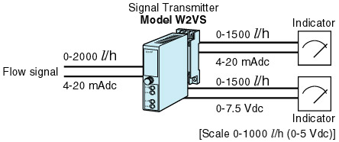
M-System has flexible solutions to meet your specific application and requirements. Consult our Signal Conditioners Data Library. 

