Air flow from a blower is being controlled remotely with a flow setter (angle setter of a damper), which is very difficult to set it.

Relation between damper angle and air flow passing though is shown in Figure 1. Between the opening range 0° (full-closed) and 45°, the air flow varies significantly according to the damper angle. However then until 90° (full-open), the variation of the air flow is much less.
In your application, the air flow is set by changing the damper angle. Therefore it is difficult to set the air flow by a linear signal from the angle setter with its proportional scale. However installing our Linearizer model M2XF between the angle setter and a motor to drive the damper will improve the situation.
Determine the characteristics of the Linearizer depending on relation between the damper angle and the air flow (Figure 3). With the Linearizer, the air flow corresponds to the output of the flow setter (angle setter of the damper) proportionally in the wide range, and setting the air flow will be much easier.
Besides setting by an angle setter, in controlling air flow by a controller without linearization function, the control performance will be also improved by installing the Linearizer as shown in Figure 2.
Moreover, in controlling flow by a valve with non-linear characteristics between valve travel and flow, e.g. butterfly valve, the Linearizer will improve the performance as well.
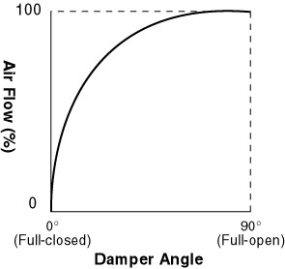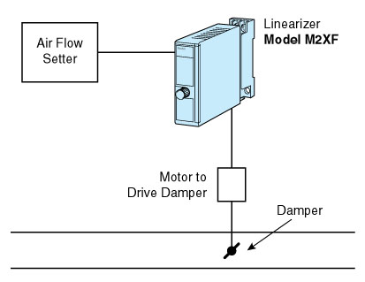
Figure 1 Figure 2
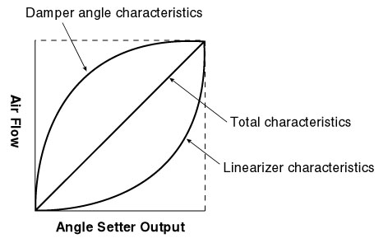
Figure 3

