A Perfect Fit!
With the proliferation of systems in our customer plants, have interface problems gone away? Not likely. The customer was sending analog signals between a turbine and a PLC. Both systems wanted to power the loop.
For one an output, the other an input. Of course we have a perfect fit for this situation in the BVS-A.
Additionally, when helping the customer trouble shoot the installation, I saw first hand the advantage of using a dropping resistor for the input, and having monitoring jacks for the output. It was very easy to trace the current signal from one point to the next. In this case we were able to find a wiring problem in a matter of minutes.
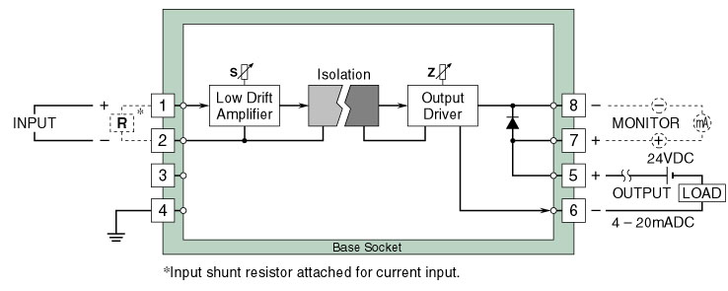
M-System has flexible solutions to meet your specific application and requirements. Consult our Signal Conditioners Data Library. 

