PLC Product Lines with NON-isolated Analog Inputs
PLCs analog capability has improved, particularly with the larger units. However, there are still many PLC product lines that have Non-isolated analog inputs.
The customer had a PLC bringing in several analog signals from the field (i.e., pump discharge, tank levels, etc.). There were several problems: several transmitters were sourcing 4-20mAdc, the PLC was also powering the loop, and the PLC had non-isolated inputs.
As you know, the BVS is a ready solution for this situation. The wiring of the BVS is much simpler than the PLC wiring. If you study the attached connection drawing long enough, you can figure out that the sourced power is on 2, and the return is on 3. That’s for loop 1, and this continues for 16 points.
In many PLCs, the BVS can keep the customer from having to use a more expensive card, or even having to go to a higher priced PLC Series. We help them keep it simple.
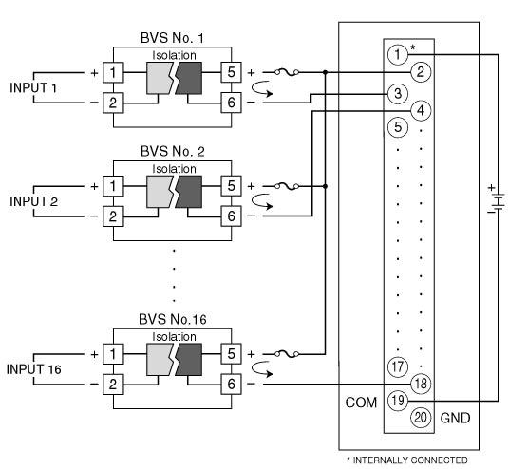
M-System has flexible solutions to meet your specific application and requirements. Consult our Signal Conditioners Data Library. 

