
An engineering company had specified an analyzer and a DCS system. During startup they discovered that both devices were trying to power the loop. Additionally the DCS was providing a common power supply for multiple loops.

There are several from M-System. However because these were spread out through the plant the BVS is the best choice. The input (from the analyzer) comes in through a dropping resistor (installed by M-System). The analyzer is powering this loop. The output as shown on the schematic diagram (see the Figure below) is powered externally (by the DCS). M-System shows a supply voltage between 12-60V dc. This is referring to the supply powering the output. Note the input is also isolated from the output. The BVS is a natural cure for bucking power supplies.
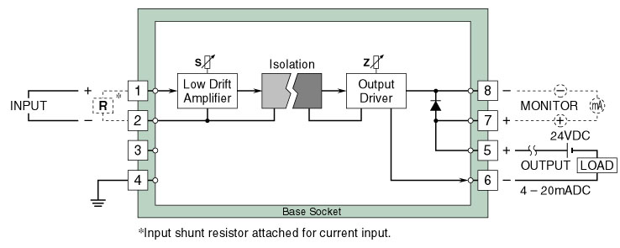
Figure: Circuit diagram of model BVS
M-System has flexible solutions to meet your specific application and requirements. Consult our Signal Conditioners Data Library. 

