
What is the difference between 2-wire and Loop-Powered?
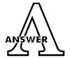
M-System’s Model M2SN is available for inputs of 4-20mAdc or 10-50mAdc and outputs of 4-20mAdc or 1-5Vdc. Many people have inquired as to the meaning and differences in terminology regarding the wiring of many of our signal conditioners. Specifically, the terms “4-wire,” “2-wire” and “loop-powered” are confusing to those who are not familiar with M-System equipment. Here are the brief explanations for these three terms regarding the M-System signal conditioning equipment.

■ 4-wire
This description refers to the relationship between the output from the conditioner and the power to the conditioner. The output is on 2-wires and the power is on another set of 2-wires.
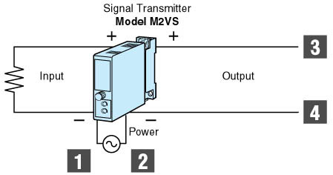
■ 2-wire
This description also refers to the relationship between the output and the power. Two-wire needs the power supply unit such as Model M2D or M2DY.
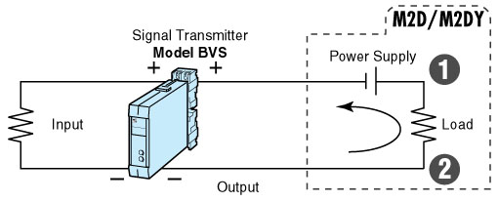
■ loop-powered
This description refers to only the incoming power to the signal conditioner. In this case, the power for the conditioner is supplied by the input signal loop. In case the customer cannot supply power in the field, you can just insert Model M2SN into the 4-20mAdc single line.
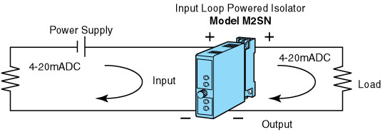
M-System has flexible solutions to meet your specific application and requirements. Consult our Signal Conditioners Data Library. 

