
We want to get 4-20mA DC from a control circuit to provide the signal to a speed controller. However, one problem is tat there is a difference in electric potential (50 to 100V) between each of the ground, the control circuit and the speed controller.

In case there is an electric potential between each instrument, it is recommended to install Loop Powered Isolator (Model M2SN) in the loop, between these two instruments.
The M2SN gets its power supply from the output of the control circuit. It is not necessary to prepare an auxiliary power.
Since the dielectric strength between input and output of M2SN is 500V ac for one minute, you can install the M2SN even under such electric potential value as 50 to 100V.
In the actual operation, make sure that (1) output load resistance of the control circuit which provides 4-20mA dc shall be 250 ohms or more, (2) input impedance of the speed controller shall be within 50 to 350 ohms.
M-System offers most versatile selections of Loop Powered Isolators. You have a lot of choices to meet your mounting requirements: space-saving, plug-in or rack-mounted, DIN terminal block or screw terminals, etc.
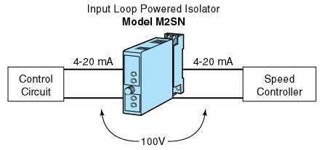
M-System has flexible solutions to meet your specific application and requirements. Consult our Signal Conditioners Data Library. 

