
It is necessary to ensure that several drives are operating exactly the same as the “master”. The “master” drive must control four separate “slave” drives from a single 4-20mA dc signal.

Each slave drive has an input resistance of 250 ohms. The first thought would be to put all of these units in series with the master drive, but the total resistance of all four slave drives (250 x 4 = 1000 ohms) would exceed the maximum load capability of the master (500 ohms).
Another concern is what would happen to the master 4-20mA signal if one or more of the slave drives failed or was taken out of service. For these reasons, we recommend to use the model W2VS that provides two independent and isolated output signals from a single unit. In this application we will need to use two fo the W2VS units in order to control four slave drives.
In addition, we selected the W2VS with an input resistance of 50 ohms so that the combined resistance of both units (100 ohms) would be less than the master’s maximum capability of 500 ohms. A seemingly minor point but a critical one that is often times overlooked when specifying interface equipment. Also, since the W2VS is a plug-in type unit, the current input resistor is installed on the unit’s base socket so that the primary loop’s integrity is maintained if something should happen to the W2VS unit or if it is unplugged from the socket.
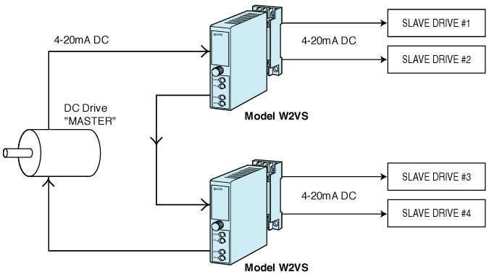
M-System has flexible solutions to meet your specific application and requirements. Consult our Signal Conditioners Data Library. 

