Beating Loop Impedance Constraints
Overall loop impedance can still be a problem. Many loop power supplies are limited in the amount of load they can support. Yet customers will still want to add another recorder or monitoring function to the loop that requires a 4-20mA signal. An M-System isolator is the answer.
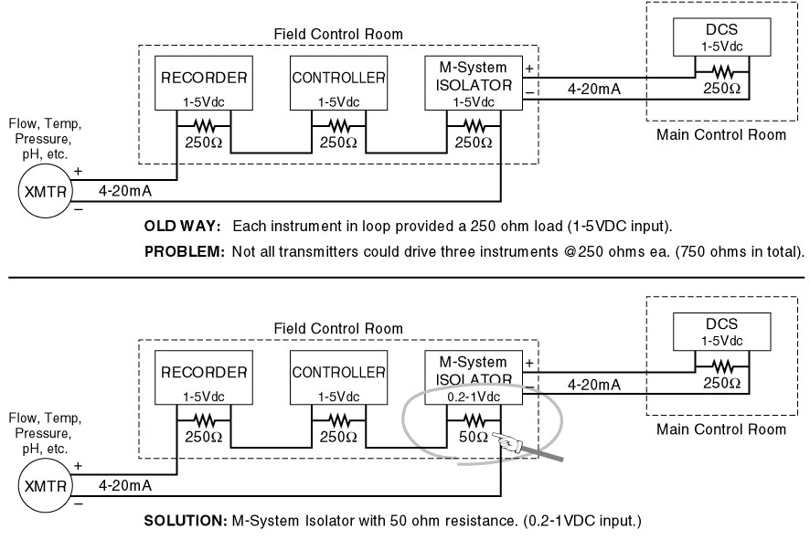
M-System has flexible solutions to meet your specific application and requirements. Consult our Signal Conditioners Data Library. 

