Which type of Isolators to choose from ?

1. Four-wire: 4-20 mA Input / 4-20 mA Output / Separate Terminals for Power
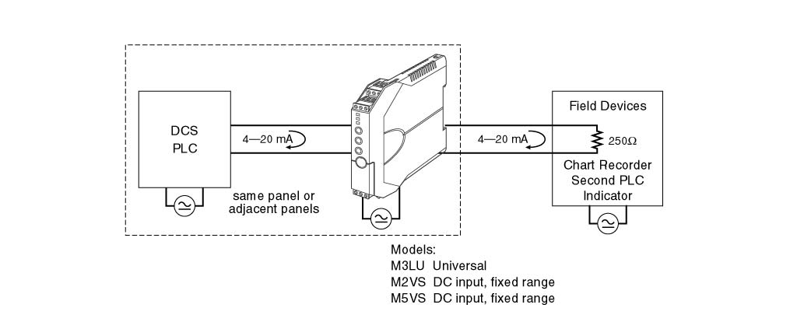

2. Two-wire: Current Loop Supply
Powering a 4-20 mA DC current loop
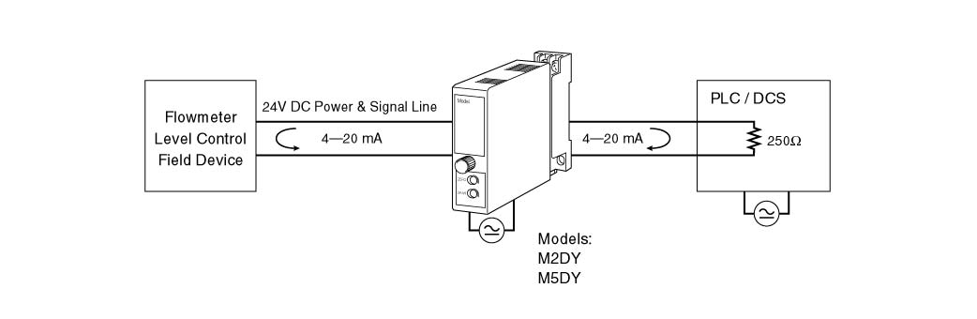

3. Two-wire: 4-20 mA Input / 4-20 mA Output (Powered) / Dual-Channel
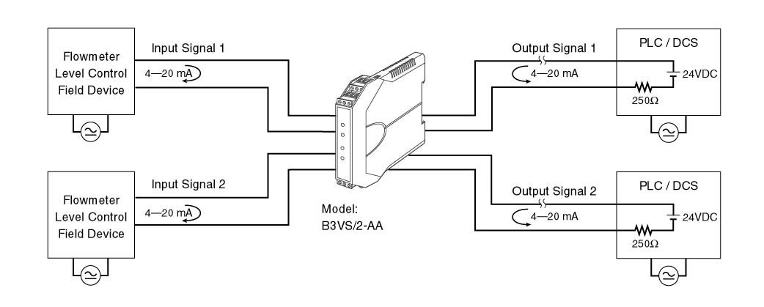

4. Two-wire: 4-20 mA Input / 4-20mA Output (Powered) / Single-Channel
5. Two-wire: 4-20 mA Input (Powered) / 4-20 mA Output
