Weighing System with Push-Button Tare
Tare: Zeroing-out function of the dead-weight on a scale (empty package weight).
The model M2LCS excites and conditions the load cell and outputs a voltage to model M2AMS, Track/hold.
The model 44DV1 digital panel meter measures the difference between input and output signals of the M2AMS. The unit is normally in the HOLD mode, with the memory control terminals (push button) open.
When you want to zero the meter, close momentarily these terminals. This turns the M2AMS into TRACK mode, which automatically zeros the meter, regardless of the weight of the load cell.
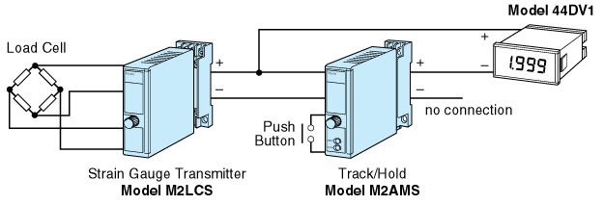
M-System has flexible solutions to meet your specific application and requirements. Consult our Signal Conditioners Data Library. 

