Measuring the Rate of Material Conveyed on a Conveyer Belt
The belt speed which is measured with a magnetic pickup is provided to model M2SP, while the belt load measured with a load cell is provided to model M2LCS. The output signals from these conditioners are multiplied by model M2MLS. Its output signal is proportional to the rate of material conveyed and is displayed on model 44DV1 digital panel meter.
The output signal can also be fed to a DC/Frequency Converter model M2AP which provides a pulse rate for the counter. The counter records the total material conveyed.
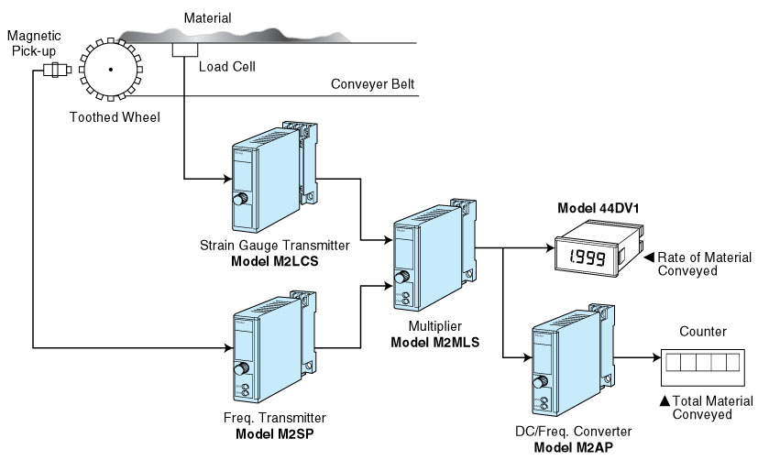
M-System has flexible solutions to meet your specific application and requirements. Consult our Signal Conditioners Data Library. 

