Measurement of Flow Output by Strain Gauge Transmitter
In general, load cells are used to measure powder and grain flow in a system utilizing a hopper.
In this case, weight of powder transferred to the hopper is calculated by the difference between initial (empty) hopper weight (X₁) and final weight of filled hopper (X₂), by the system illustrated below:
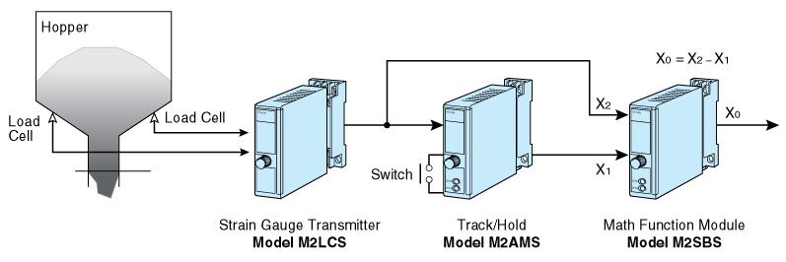
[Procedure]
- Before the hopper is filled, Memory Switch of the Track/Hold is turned on in order to hold initial weight (X₁).
- The Math Function Module determines actual weight of the load by equation X₀= X₁- X₂.
- Finally, Memory Switch of the Track/Hold is turned off, X₁ becomes equal to X₂, and X₀ returns to 0.
M-System has flexible solutions to meet your specific application and requirements. Consult our Signal Conditioners Data Library. 

