Zero Point Compensation for Strain Gauge Transmitter
In general, load cells are used to measure powder and grain flow in a system utilizing a hopper and CFW (Constant-Fed Ware). Since powder tends to stick to the hopper and CFW, following zero-point compensation for strain gauge transmitter output is required to compensate a batch for power remaining in the hopper from the previous batch:
- The weight of residual in the hopper before powder loading (as measured by the load cell) should be subtracted from the weight measured after loading powder into the hopper.
- It’s also necessary to compensate for zero offset caused by powder sticking to load sensing rollers in the CFW.
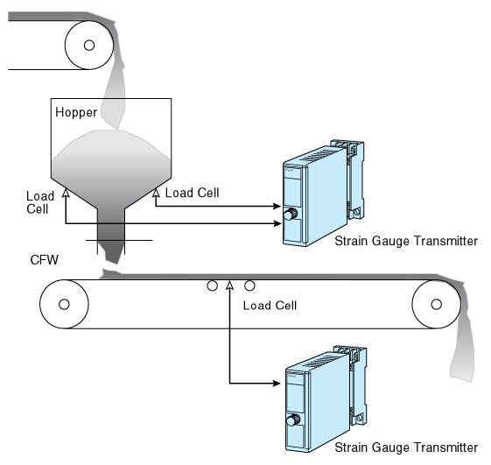

By combining a Math Function Module M2SBS with a Track/Hold M2AMS, its possible to compensate the zero point of the Strain Gauge Transmitter M2LCS output (refer to Figure 2). To provide an absolute zero-point offset, turn the Hold command switch on. For example, if the zero is offset by 5% (high), X₁ is held at 5% so that when the actual measurement value is X₂, corresponding output of the Match Function Module is X₀ =X₂ ─ 5.
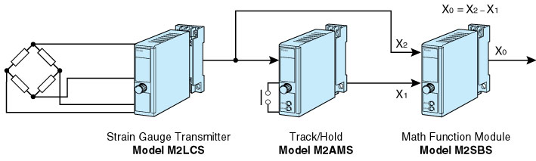
Figure 2

