
We use M-System's strain gauge transmitter model MXLCF. When we re-adjust the excitation voltage to 6V, which is the recommended value of the strain gauge, the indicator displays 20% greater (=6 tons) than the actual load (5 tons = input 50%).

Without otherwise specified, the excitation voltage of our strain gauge transmitters is factory adjusted to 5V.
As the rated output from the strain gauge in this question is 2mV/V, input signal to the transmitter will be 0-10mV (2mV/V x 5V). If you change the excitation voltage to 6V, input to the transmitter will be 0-12mV (2mV/V x 6V). In other words, though the output from the strain gauge is actually 50% (5 tons), input signal to MXLCF will be 6mV (60% of 10mV span) with 6V excitation, and the indicator naturally displays 6 tons.
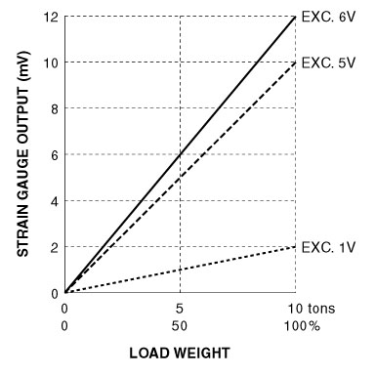
To have an output signal from the strain gauge, it is necessary to supply voltage to it. This voltage is called excitation voltage. Recommended excitation voltage of the strain gauges is MAX. voltage which satisfies their specifications but is not always essential. Less voltage is available depending on the transmitter’s performance. In this case, you do not have to readjust the excitation voltage to 6V, stay with the factory-adjusted 5V.
As M-System’s strain gauge transmitters are equipped with the amplifier which realized excellent performance with low excitation voltage, you can have stable output signal with 4V excitation even if higher value is specified in the specifications of a connected strain gauge.
If you need different rated output from that described on the specification label on the transmitter, you can use the excitation adjustment with following equation:
M-System has flexible solutions to meet your specific application and requirements. Consult our Signal Conditioners Data Library. 

