
I have an application involving the simple need to convert a millivolt signal from a load cell into a 4-20mA DC to go to a PLC. Our load cell is calibrated for 2mV/V with a 10V dc excitation supply. Which unit should I use?

The M-System model M2LCS-2A would be a perfect fit for this application. Calibrated for 2mV/V @10V excitation, the M2LCS would actually see an input range of 0-20mV DC (2mV x 10V excitation). The M2LCS then converts this voltage range into a 4-20mA DC signal. The M2LCS also provides the excitation via its onboard power supply.
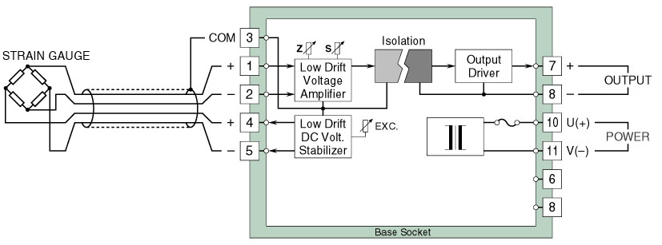
Alternatively, this application could also be solved using a model M2VS-0A calibrated 0-20mV DC with the use of an external power supply.
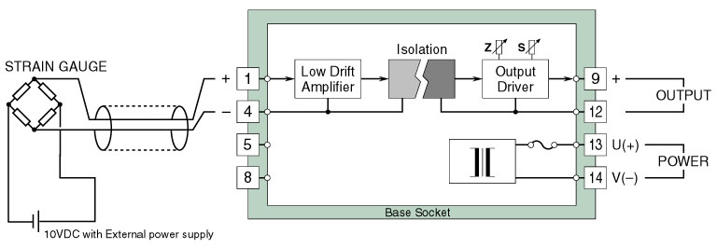
M-System has flexible solutions to meet your specific application and requirements. Consult our Signal Conditioners Data Library. 

