Temperature measurement of generator’s motor bearings
The public utility district is a supplier of electricity who has many generators that they use to manufacture this electricity, varying in size and output capacity. These generators have 10Ω copper RTD sensors installed to monitor the temperature of the motor bearings (see the figure). These RTDs are installed by the manufacturer of the generators during their production process. If a critical temperature is reached, then the generator must be shut down to avoid permanent damage or failure.
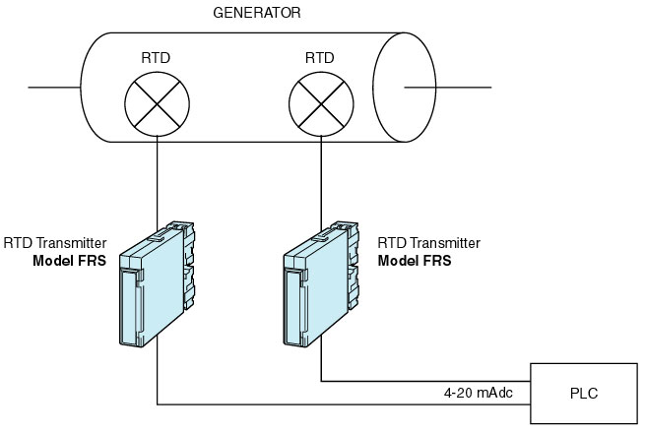
These RTD sensors are connected to M-System model FRS transmitter with 4-20mA dc outputs that can be sent to both PLC and data acquisition equipment. The PLC will shut down the generator if the temperature exceeds the preset limits. These generators create a very large magnetic field during operation. The model FRS is used to convert the 10Ω copper RTDs and isolate the output signal from the magnetic field induced. In addition to FRS units, they also use model LSMT multi-power transducers to monitor the output of these generators. These outputs (V, I, W, Hz and PF) are then sent to a data acquisition system which trends this information for operation interface and review. All units must be powered from 120V dc power (battery backup system) because they must be operational 24 hours a day.

M-System has flexible solutions to meet your specific application and requirements. Consult our Signal Conditioners Data Library. 

