
To manage a vinyl house efficiently, I want to monitor the room temperature as well as the temperature difference from the outside temperature. How can I realize the flowing two functions?
A: indicating the room temperature.
B: providing an alarm signal when the temperature difference exceeds a preset value. The temperature detection sensor is RTD.

A: M-System’s RTD Transmitter model M2RS convert the room and the outside temperatures into 4-20mA dc respectively and the Bargraph Indicator model 48V shows the room temperature.
B: Connect the signals of the room and the outside temperatures to the Deviation Alarm model AYDV to provide an alarm for their deviation.
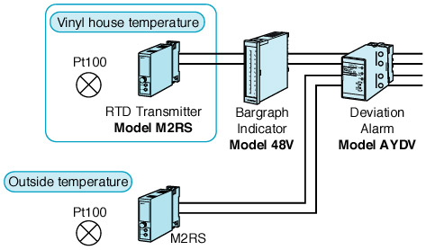
M-System has flexible solutions to meet your specific application and requirements. Consult our Signal Conditioners Data Library. 

