
We have a project to measure the temperature of a deep well about 1000 meters under the ground with Pt100Ω, resistance temperature detector. Do you have any idea on this?

Generally, the 0.5 mm diameter cable’s resistance is about 100Ω per 1 km (0.62 mile). If you use 0.5 mm diameter or longer cable to RTD sensor (Pt100Ω), M-System’s RTD transmitter, model M2RS meets your application. M2RS applies 2 mA current to Pt100Ω and allows 200Ω of leadwire resistance per wire between RTD sensor (Pt100Ω) and M2RS.
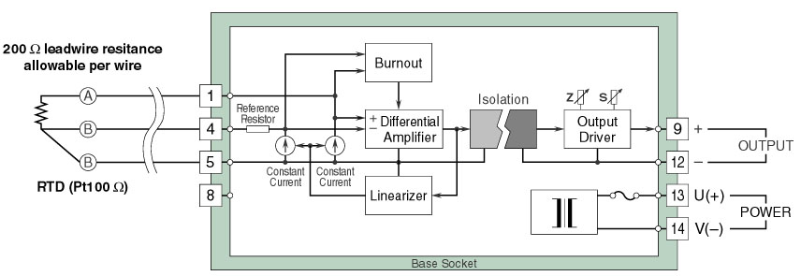
In this case, the depth of the well is about 1000m and leadwire resistance is estimated about 100Ω per wire. Therefore there is no problem for M2RS to measure temperature of the well, 1000m depths. Upscale burnout is standard but downscale or no-burnout available as an option.
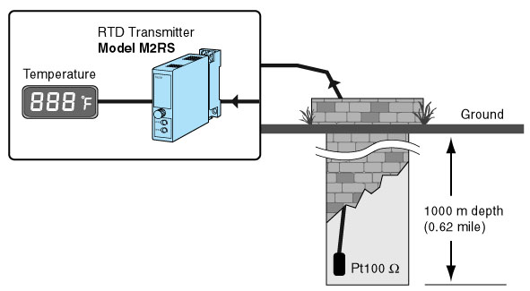
M-System has flexible solutions to meet your specific application and requirements. Consult our Signal Conditioners Data Library. 

