
When opening a door of a transmitters’ panel, the output of the M2TS becomes unstable. Why?

Compensating leadwires are not connected to the input terminals of M2TS, but wired to a terminal box 10 cm before the transmitter. The compensating leadwires should be connected directly to the input terminals of M2TS.
The secret of temperature measurement with a thermocouple is how correctly the transmitter can measure the temperature where the compensating leadwires are connected. In this case, when the door is open, due to the temperature difference between output and inside the door, temperature error between the terminal box and the input terminals of M2TS makes output unstable.
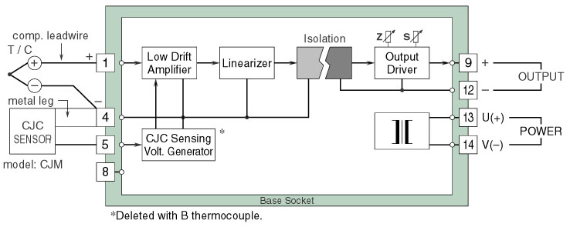
Circuit Diagram of model M2TS
M-System has flexible solutions to meet your specific application and requirements. Consult our Signal Conditioners Data Library. 

